MS Wireless Communication Commission
412 East Woodrow Wilson Ave, Mail Stop 6601
Jackson, Mississippi 39216
Phone: 601-359-5333; Fax: 601-359-5362
mdenham@wcc.ms.gov
WCC Action: __________________ Date: _______________
Project Title:
Contact Information
Local Governing Authority: _________________________  Address: __________________________________________  _______________________________________________  Department: ______________________________________ |  |  | Contact Person: _______________________________________________  Phone: _______________________________________________________  Fax: _________________________________________________________  Email Address: ________________________________________________
Project Summary

Project Type: New System____ Upgrade/Enhancement to Existing System ____ System Expansion ____ Maintenance ____
Narrative Description of Current System and Proposed Project including a timeline for implementation (Attach additional sheets if needed.)

Discuss Funding (Total project budget, source of funds, i.e., Homeland Security, local revenue, grants, other state or federal funding)

Acquisition Details (Attach additional sheets as needed)
Items Requested:  Item | Quantity | Description |  | Manufacturer | Purchase Cost
 |  |  |  |  | $
 |  |  |  |  | $
 |  |  |  |  | $
 |  |  |  |  | $
 |  |  |  |  | $
TOTAL |  |  |  |  | $

Acquisition Method: Competitive bid by requesting entity: __________ Radio EPL: __________ Quotes: __________

Existing Contract by requesting entity: __________ MSWIN Motorola 3429: __________ Other: __________
If “other,” specify method:
Critical Factor(s): What is driving this acquisition at this time?

MS Wireless Communication Commission


Procurement Request

__________________________________________ __________________________________________
Name (Presiding Officer) / Title Signature Date

Please Attach:
- Official Board Order or Certified Copy of Minutes authorizing this project
- For radio acquisitions, answers to General Analysis Questions: Local Government Radio Acquisitions
- All Vendor price quotes

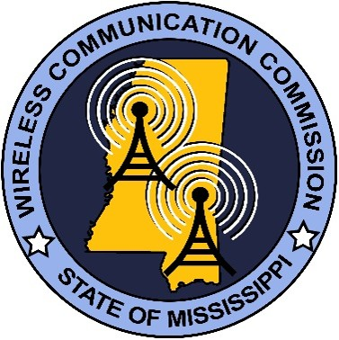 | MS Wireless Communication Commission  412 E Woodrow Wilson Ave Mail Stop 66-01  Jackson, MS 39216
MSWIN Analysis Questions:
Government Radio Acquisitions
(Note: Requestor should coordinate with ITS, the WCC, and/or the incumbent vendor, as required,
to thoroughly and accurately answer each of the questions listed)

- What is needed/being requested?

- What is the impact of the local project on the state MSWINS project?

- What is the potential impact of the state MSWINS project on the local project(s)?

- How can shared facilities (equipment and infrastructure) be leveraged to benefit one or both projects?

- How does the proposed technology mesh with the state’s technical implementation?

- Describe where the differing technologies fit on the technology roadmap. Is there a defined migration path from the older to the more recent technology solution?

- Is the equipment purchase prices consistent with or better than the state contract prices and discounts?

- What level of interoperability with the state and other local systems will this implementation achieve?

MS Wireless Communication Commission
412 E Woodrow Wilson Ave Mail Stop 66-01
Jackson, MS 39216

Procurement Checklist

Requests must be submitted 30 days prior to the Procurement Committee meeting. The
Committee normally meets on the first Thursday of each month before the Commission meeting.
Click here to confirm meeting dates.

All requests must include:

- Procurement Request Form
  - Project Title
  - Contact Information
  - Project Summary
  - Acquisition Details
  - Name, Signature, & Date

- Analysis Questions

- Official Certified Minutes
  - If the official certified minutes are not available when the package is submitted,
you may include the unofficial minutes to start the process.
  - No request can be fully approved until the official minutes are received in the
WCC office.

- Acquisition Quote(s)
  - All quotes are to be submitted.
  - Quotes are verified by WCC staff. Please ensure that your vendor has complied
with the EPL or Motorola RFP 3429 prices. Any discrepancies could delay
the procurement approval.

Approval Thresholds:
- Procurement Review Committee ($100,001-$250,000)
- Wireless Communication Commission (over $250,000)

